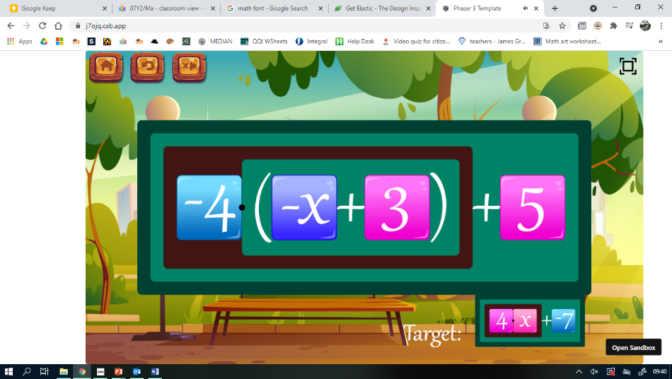**Maths** Sign in



# Smplfy

Practice simplifying algebraic expressions including expanding and factorising brackets (and algebraic fractions).

More ⮛

# Learn the rules of arithmetic including identity elements, commutativity, associativity and the distributive law. (Hidden under a “More” button)

🖂 © Elastic Maths 2021

# Solve

Practice solving equations.

More ⮛

Solve equations using the balance method. Includes equations with brackets, unknowns on both sides, (fractions), equations requiring factorisation, and rearranging formulae (Hidden under a “More” button)

2: Associativity/Commutativity of Addition: <https://www.pbslearningmedia.org/resource/mgbh.math.nf.commprop/commutative-and-associative-properties-of-addition/>

0: Adding zero: <https://video.link/w/PzP2c>

1: Additive inverse: <https://www.pbslearningmedia.org/resource/muen-math-ns-addinverse/additive-inverse/>

5: Multiplying by 1 and 0:

[https://video.link/w/o1P2c](https://video.link/w/o1P2c 6)

[6](https://video.link/w/o1P2c 6): Multiply by -1: <https://vimeo.com/529684708>

7: Commutativity of Multiplication: <https://schoolyourself.org/learn/algebra/multiplication>

8: Distributive Property: <https://www.pbslearningmedia.org/resource/muen-math-ee-equivexp/equivalent-expressions-with-the-distributive-property/>

9: Distributive Property with Variables (inc factorising): <https://www.pbslearningmedia.org/resource/mgbh.math.ns.distprop/distributive-property-with-variables/>

10: Prime factorisation: <https://video.link/w/a1Q2c>

**Teacher Dashboard**

Side-bar

* Classes (users feather icon)
* Resources (folder)
* Feedback (send)

Classes

* Create new class
  + Name
* List of classes previously created
  + Name
  + No. of students
  + Pin to top button
  + Delete class

Class

* Name of student
* Last log-on
* Remove student
* Smplfy progress
  + Grid with list of students against…
  + Each level heading
* …

Resources

* List of google slides and pdf activities

Feedback

* Form to fill in that sends an e-mail to me.
  + Name
  + E-mail
  + Role
  + Type of feedback
  + Message
  + Submit